SUMMERVILLE CREDIT UNION · CONSOLIDATED MEMBER GUIDE · CSUM-08 of 30
Transfer to Other Credit Union Members

Module: nFinia Digital Banking > Move Money > Other Members
Sources: Summerville Reports Series A (36 docs) + Series B (25 docs) | Features: nFinia Documentation Features Spreadsheet
01 PRODUCT SUMMARY

The Transfer to Other Members feature allows authenticated members to send funds directly to another member's account at the same credit union. This peer transfer is ideal for splitting expenses, paying back family members, or making informal payments within the credit union network. The workflow mirrors the own-account transfer but requires selecting a saved recipient or entering the destination member's account number.
Multi-recipient member transfers are also supported, allowing members to split a single payment to multiple recipient accounts in one transaction — useful for household expense splitting or distributing funds to joint family members.
Transfers are processed the same business day, and the recipient's account is credited automatically. No additional verification is required for amounts within the standard limit.

At a Glance

Attribute | Detail
Module | Move Money > Transfer to Other Members
Recipient Type | Other members at the same credit union
Multi-Recipient | Supported — split payment to multiple members in one transaction
Transfer Speed | Same business day
Steps | 4 (From → Recipient → Amount → Confirm)
Related Reports | CSUM-06 (Move Money Hub), CSUM-11 (Recipient Management)

02 KEY USE CASES

Use Case | Who Uses It | What They Do | Business Value
Family Reimbursement | Members repaying family at the same CU | Select family member recipient, enter amount, confirm | Instant digital payment replaces cash or a check
Shared Expense Split | Roommates or partners at the same CU | Send each person's share to their member account | Digital alternative to cash splitting of shared bills
Multi-Member Distribution | Members distributing funds to multiple family members | Use the multi-recipient feature to split a single transaction | One transaction instead of multiple individual transfers
Member-to-Member Gift | Members gifting funds to another CU member | Select recipient, enter amount, add memo gift note, confirm | Instant digital gift within the credit union

03 STEP-BY-STEP GUIDE

Navigation: Dashboard > Move Money > 'Transfer to Other Members'.
Step 1 — Start from Dashboard
The member begins at the Dashboard after logging in. The Dashboard displays all account balances, upcoming payments, quick-action tiles, and the top navigation bar with links to Accounts, Move Money, and More.
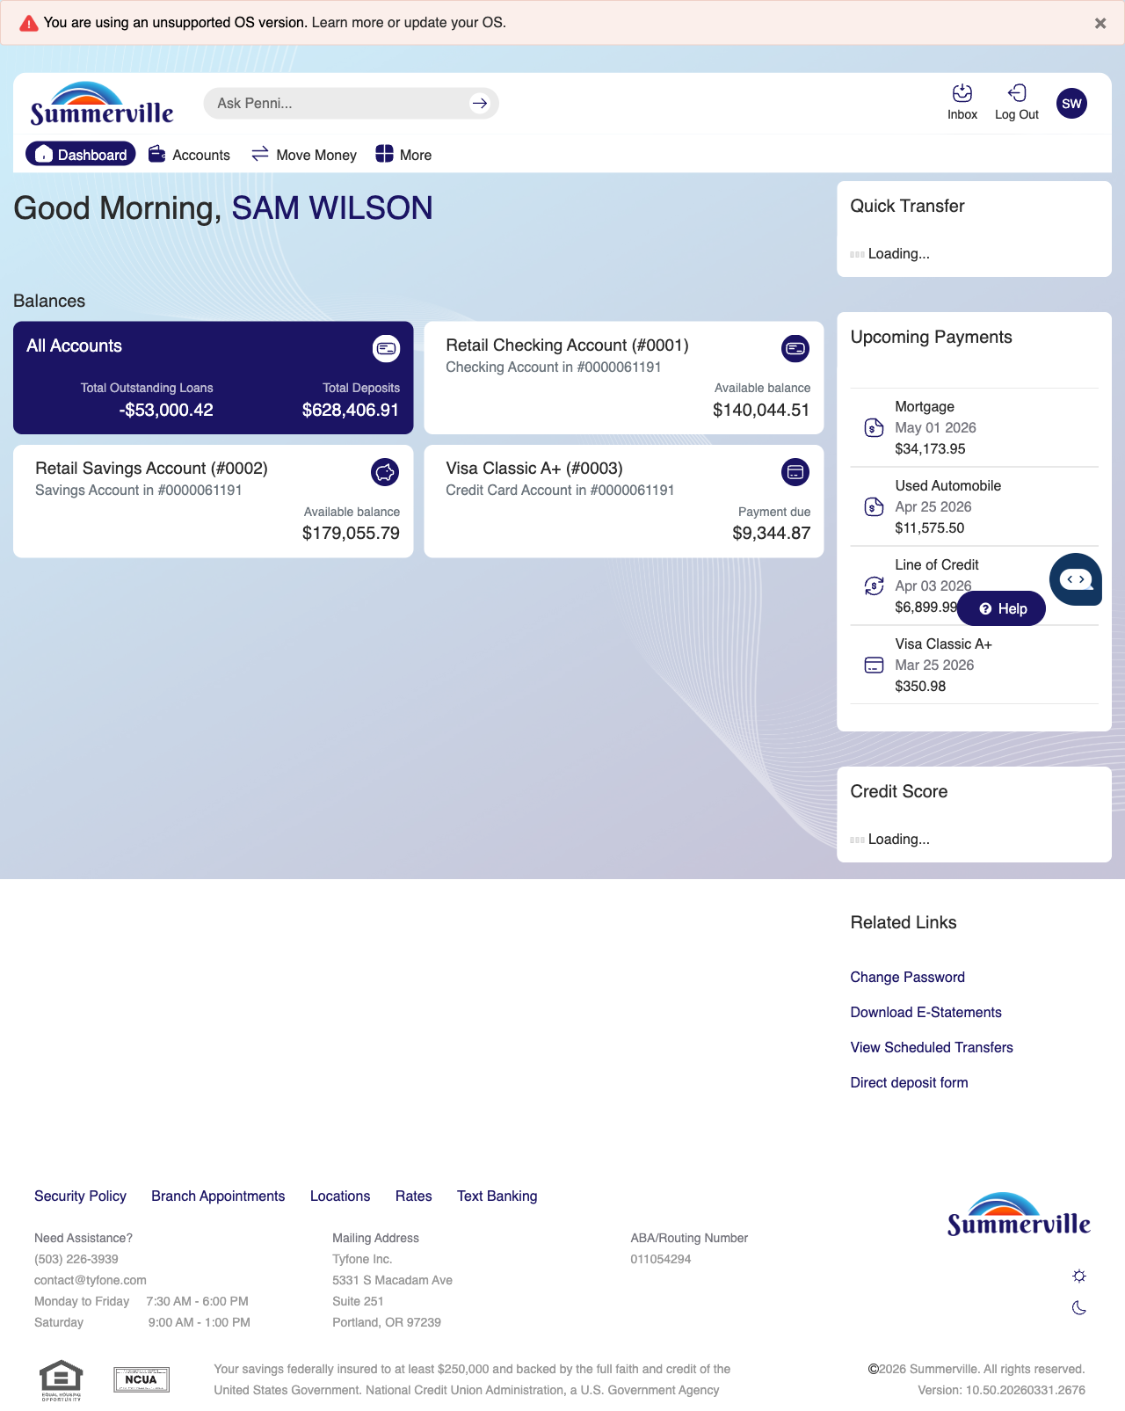
Step 1: Start from Dashboard

Step 2 — Navigate to Move Money Hub
The member clicks ‘Move Money’ in the top navigation bar. The Move Money Hub displays all payment and transfer options as tiles including Pay Bills, Quick Pay, Zelle Payment, Internal Transfers, Other Members, Same-Day Transfers, Send Instantly, Manage Recipients, Add Recipient, Transaction History, Scheduled Transfers, and P2P Transfer.
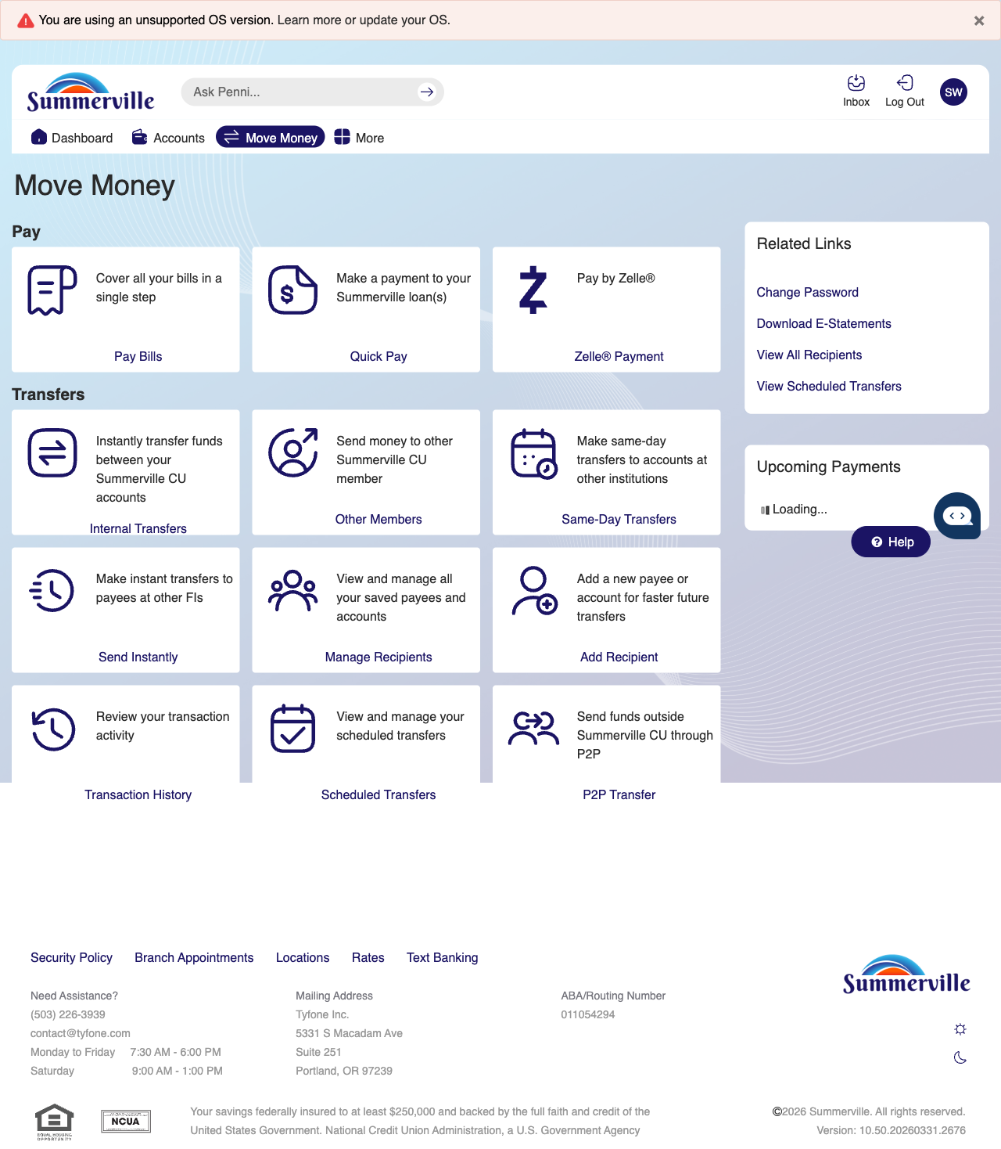
Step 2: Move Money Hub

Step 3 — Navigate from Dashboard to Other Members Transfer
The Move Money hub is displayed with a tooltip providing help for selecting a recipient. This is the starting screen for the Transfer to Other Members workflow.
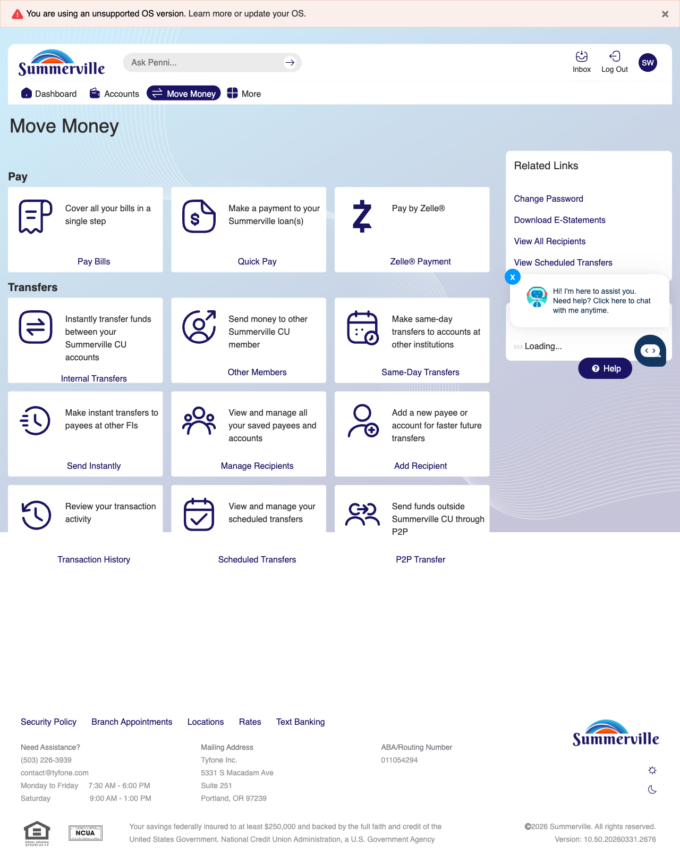
Step 3: Navigate from Dashboard to Other Members Transfer

Step 4 — Select Recipient & Enter Details
Step 2 of the other member transfer shows the account selection screen with a message indicating no eligible accounts and a modal prompting the member to select a recipient.
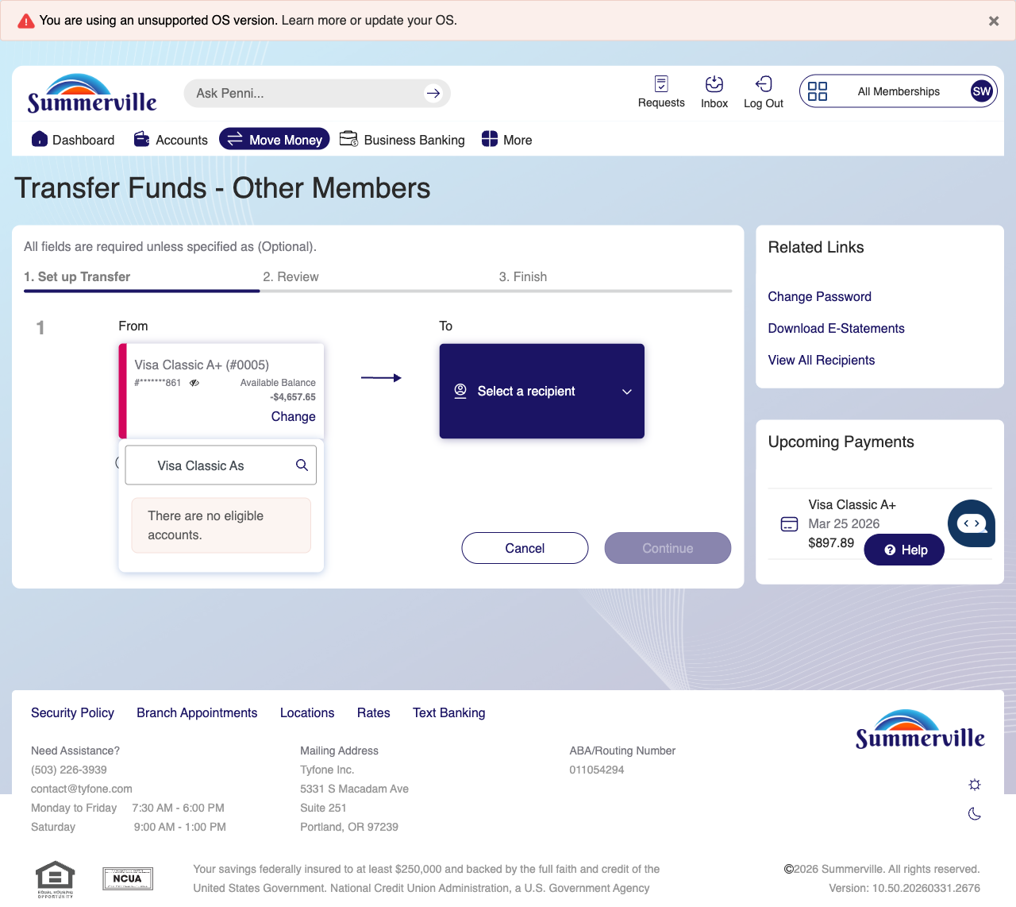
Step 4: Select Recipient & Enter Details

Step 5 — Review Transfer Summary
A confirmation overlay displays the transfer details for a $5.00 transfer, showing the source and destination account information for member review before submission.
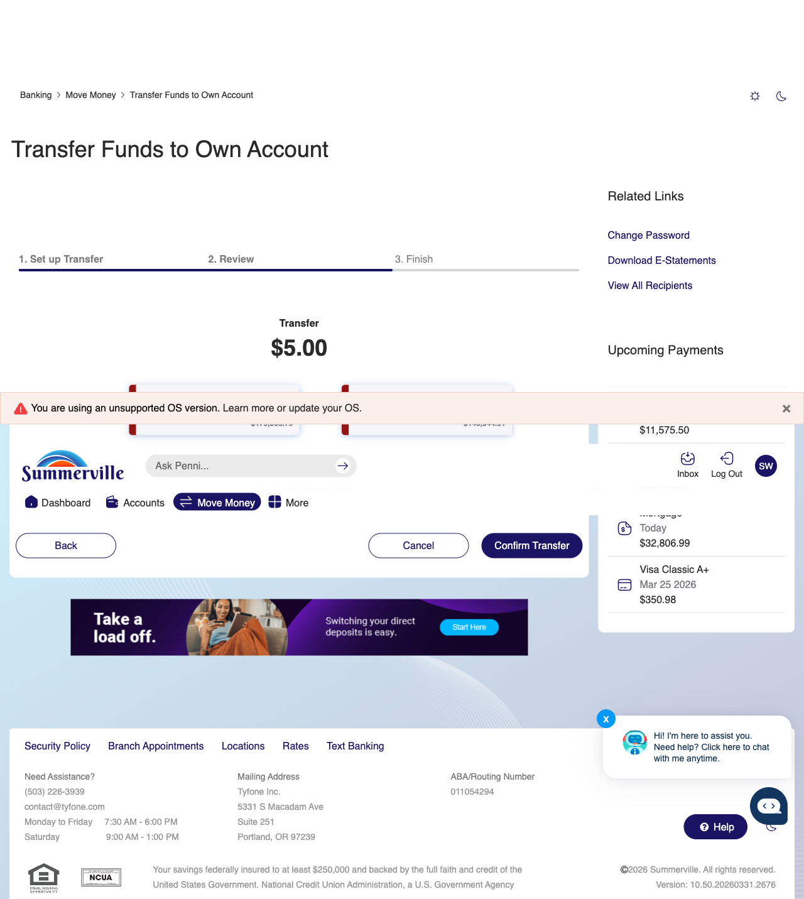
Step 5: Review Transfer Summary

Step 6 — Transfer Complete
The success screen confirms the $5.00 transfer to another member with a green checkmark, displaying the transaction details and transfer date.
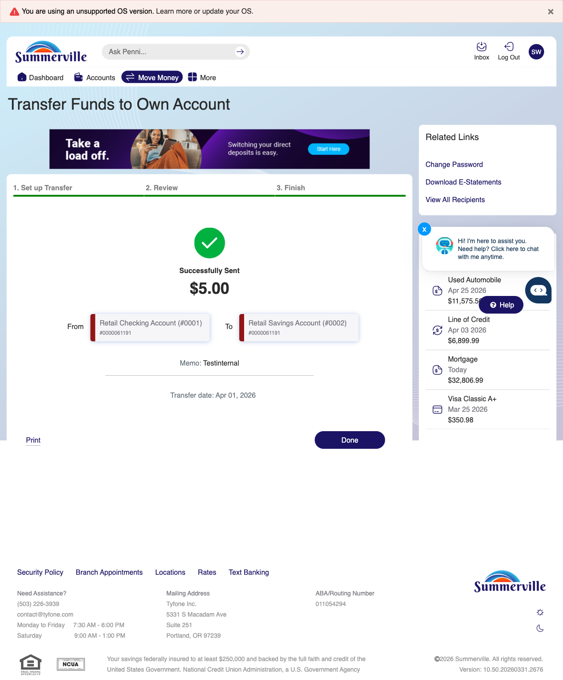
Step 6: Transfer Complete

